Family Living Program Report
April – May 2016

Programming Efforts:
The programs, Strengthening Families (recently completed) and Taking Care of You (4 of 8 sessions completed), have been a cross-programming educational opportunity for county residents. The SFP is a 12 week program designed for families with children 4-10 years. This session included parents, grandparents, and children and has been co-facilitated by colleagues from the Extension Office as well as trained community members.
Taking Care of You is currently being held in Melrose with community residents participating.

The programs, Managing Family Finances and Community Resources for Families and Individuals, were presented to inmates at the Black River Correctional Center. During the Managing Finances session, participants completed a goal-setting exercise that included the amount of finances needed to meet goal, timeline for completing and who would be involved in supporting the completion of goal. Follow-through on the exercises and discussion will be taking place in the BRCC classroom to encourage the completion of the final steps.

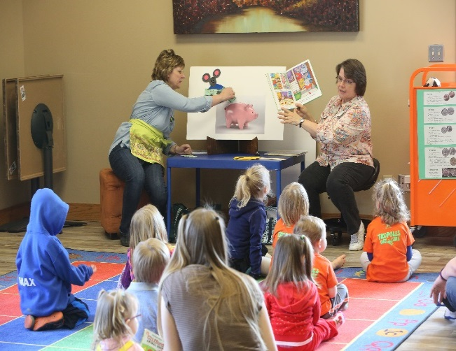
Worked with Youth Services Coordinator to meet with children and parents/grandparents/ guardians/childcare providers at the BRF Public Library Story Time to read and complete activities for the Money Smart Awareness campaign, a nation-wide effort to involve more people in being aware of the importance of saving money.

Participated in the wisline training for Powerful Tools for Caregivers of Children with Special Needs. Will be planning with other trained facilitators from the county to provide the program using this curriculum as well as the original curriculum designed for Caregivers of Adults with Chronic Illnesses. The original curriculum has been offered in the county for the past 10 years.

Support Opportunities:
Working with Jackson County Home and Community Education (HCE) organization as advisor and on upcoming programming for members and the community.
Met as a county partner with the Childhood Coalition.
Attended Joint Council of Extension Professionals (JCEP).

