4-H Youth Development Team
April 2016 Highlights

4-H Outreach:
- HCN Youth Services Family Night – Easter theme – We planted grass seed “chia heads” with the youth and families. Putting soil and grass seed into the toe of a nylon, we “planted” them in a cup and gave each “head” either bunny ears or a set of antennae, googly eyes and a face with instructions for how to water and provide sun so the “heads” grew green grass hair.

Volunteer Development:
- 4-H Adult Volunteer Orientation Training – I trained 6 adults as new 4-H adult volunteers. Five of them were from the Horse Project and one from the Dog Project (a youth who graduated from 4-H last year and already wants to come back and help younger children).
- 4-H Volunteer Background Checks Process Change – The 4-HYD Agent and support staff work together to conduct background checks for 4-H volunteers. Newly trained volunteers must be background checked before they begin, and experienced volunteers are re-checked every 4 years. Jackson County 4-H pays for those checks as part of 4-H’s Youth Protection Policy. We’re transitioning to a new system of background checks conducted by the state. They’re starting by doing the 4-year re-checks through a secure online system. It’s gone smoothly so far, so in the next couple of years, the state plans to take over doing checks for all new volunteers as well.

Strengthening Families:
- Taking Care of You – We completed 2 rounds of TCY sessions in Black River Falls and have only 2 weeks left of another round in Merrillan with school staff. Another session is scheduled to begin in Melrose on April 19 and already 5 people are signed up. We conducted an overview session for BRF WTC students which 6 students attended; as a follow-up to that, we have contacted one of the students who was interested in coordinating the full 8-week training for her workplace.
- Teens Against Bullying Others – 9 Lincoln High School students learned how to teach anti-bullying skills to 7th and 8th grade students in March. On end-of-program surveys, they reported learning the most about how to create a safe space for participants, and how to use good listening skills in teaching lessons. The teen leaders taught 45 students about getting out of your comfort zone socially, identifying things you have in common with others, how to be an ally in a bullying situation. BRF students will be doing the same during the second week of April.
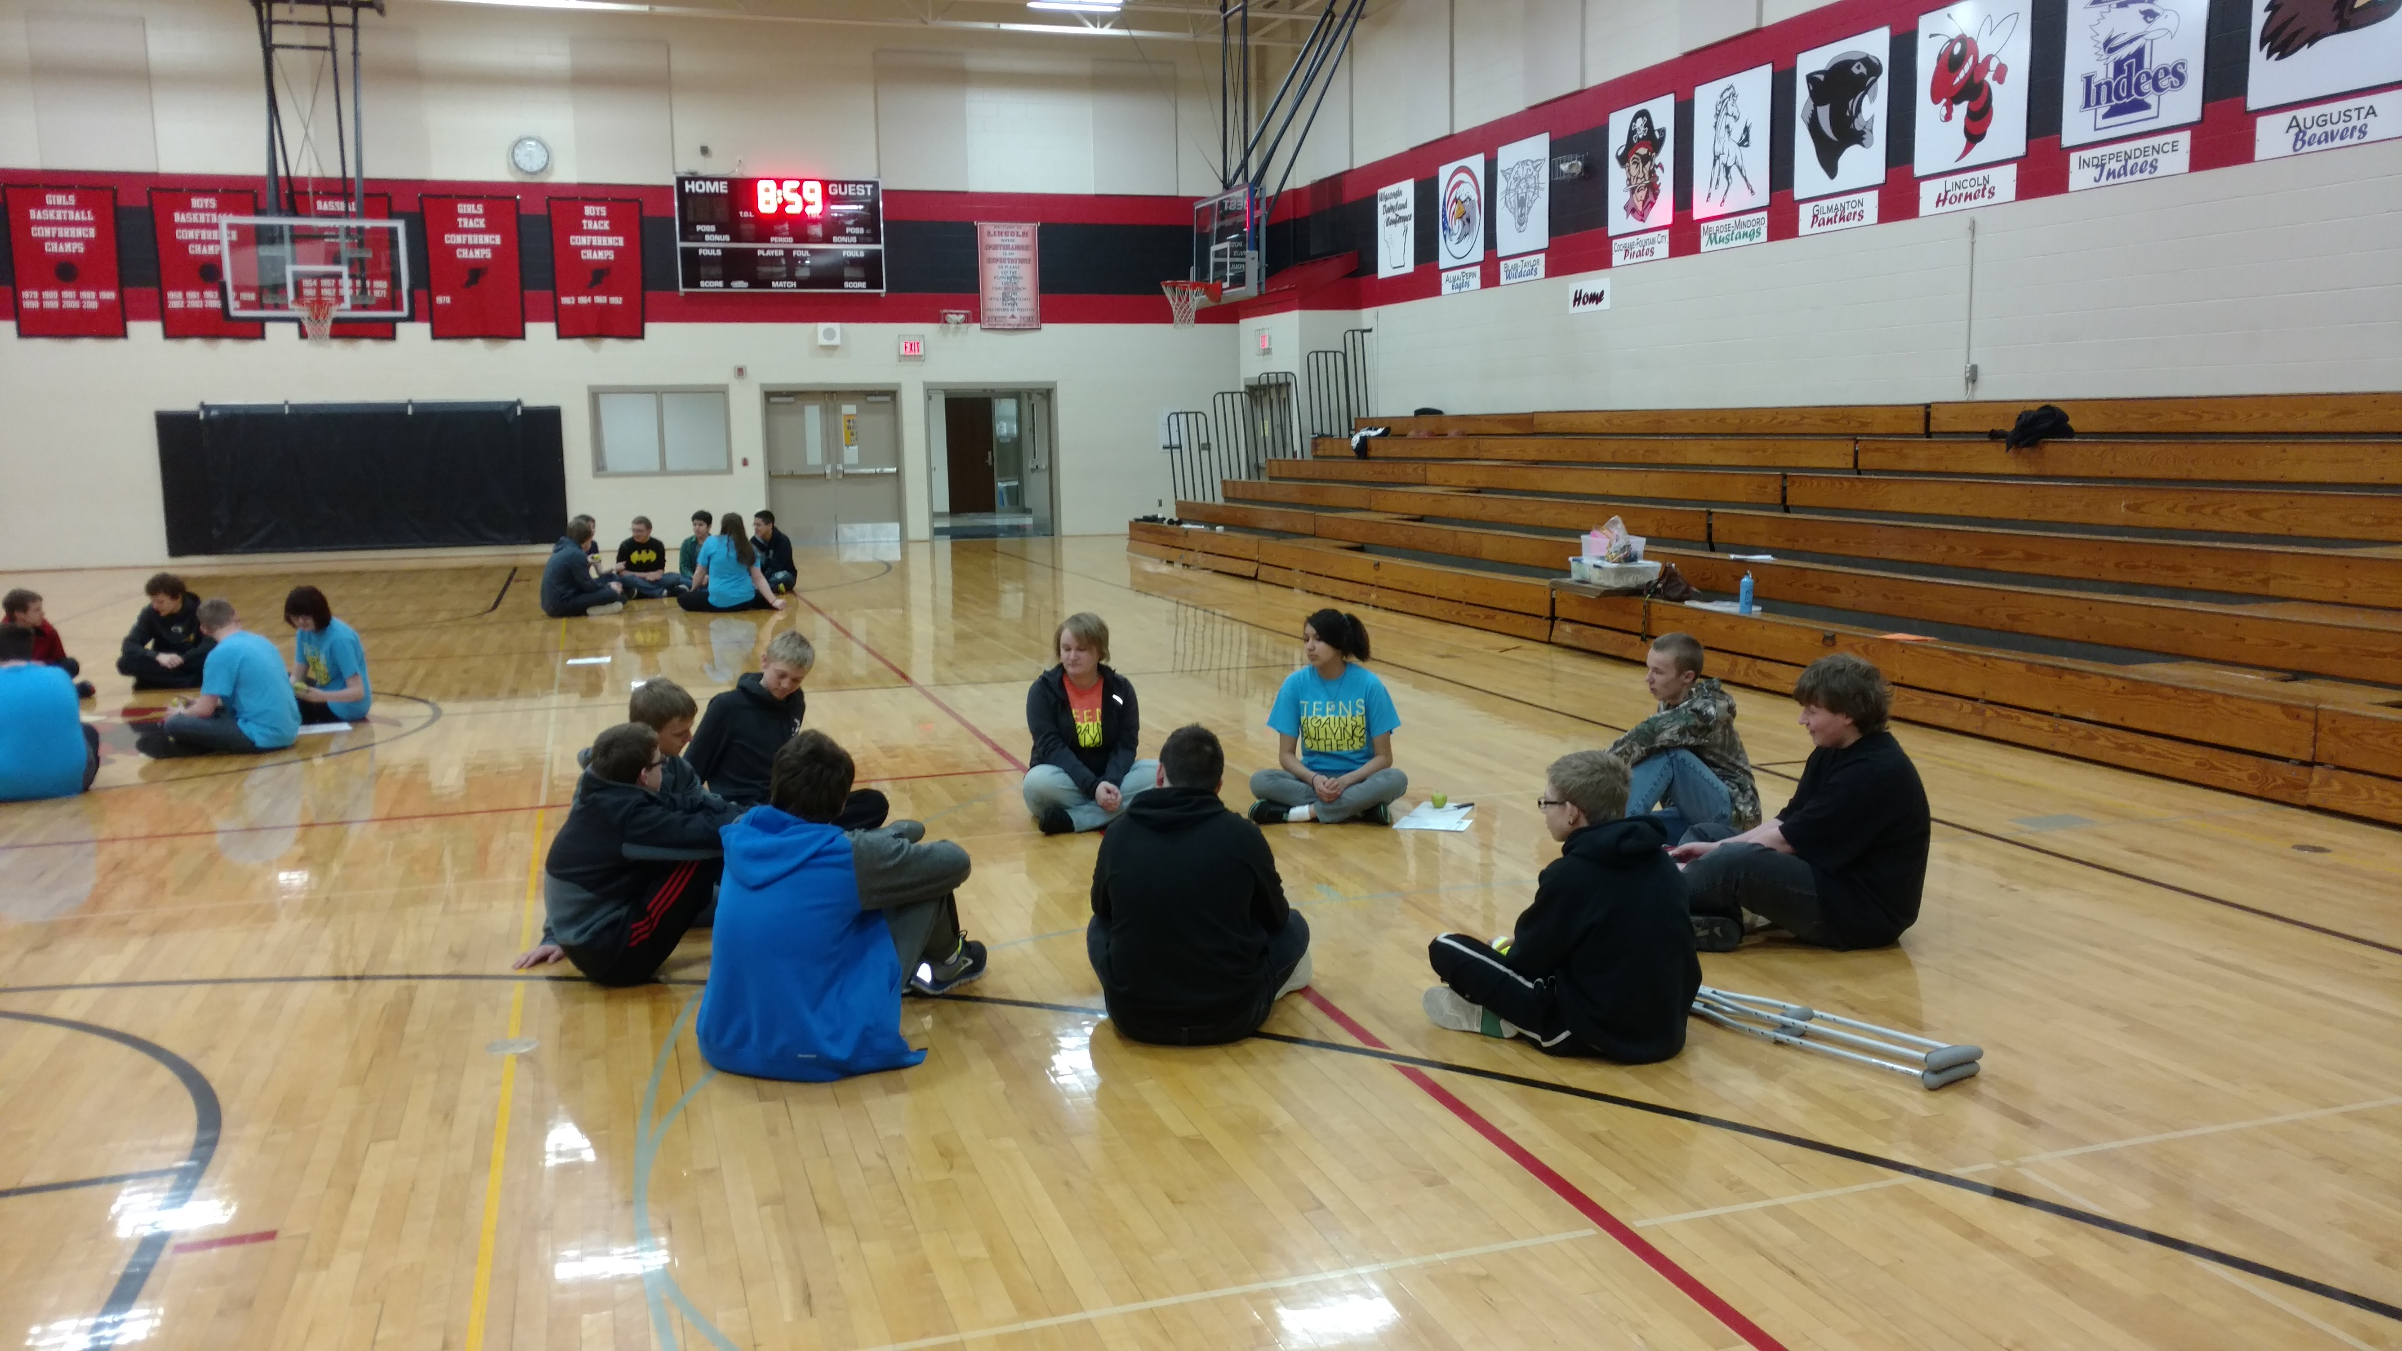

Key Meetings:
3/14 – TFJCK Leadership Team
3/15 – SQUAD meeting
3/16 – Regional 4HYD meeting
3/21 – HWPP prevention levels subcommittee meeting; 4-H Parents & Leaders Board mtg (with SPIN Club volunteer development session)
3/23 – WPP harm reduction meeting
3/39 – HWPP prevention levels subcommittee mtg
4/1 – Office Retreat
4/4 – HWPP Statewide Grantee mtg
4/5 – Staff mtg
4/6 – Tobacco Free Coalition mtg; WPP Conf Call

Trainings/Workshops Facilitated/Led:
3/14, 3/21, 3/28, 4/4 – Taking Care of You (BRF) (Monica & Alex)
3/14 – 4-H Volunteer Training
3/15, 3/22, 3/29, 4/5 – Taking Care of You (Merrillan) (Monica & Alex)
3/15, 3/22, 3/29, 4/5 – Strengthening Families (Monica & Alex)
3/17 – TABO Teen Leader Training (Lincoln) (Monica & Alex)
3/18 – TABO Teen Lessons (Lincoln) (Monica & Alex)
3/22 – HWPP Partnership Council meeting (Monica & Alex)
3/30 – TCY Overview Session at WTC; HCN Youth Services Family Night (Monica & Alex)
On-going bi-weekly TABO meetings (Alex)

