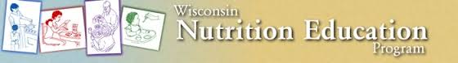

April Duval, Coordinator:

WNEP Projects & Events:

* UW-Extension All Colleague Conference, Madison, WI
* Leading the training of new Nutrition Educator, Sandy

Educational Programming in Jackson County Schools:

School | Grade | Lesson Topic | Number of Students
Forrest Street Elementary | 4K:  2 lessons  8 classes | Fruits and Vegetables  Family Meal Time | 103 students
Alma Center/ Humbird/Merrillan:  Lincoln Elementary | 2nd Grade:  1 lesson,  2 classes | My Plate | 37 students
Alma Center/ Humbird/Merrillan:  Lincoln Elementary | Kindergarten:  1 lesson,  3 classes | My Plate | 48 students
Ho-Chunk | 4K:  1 class | My Plate | 20 students
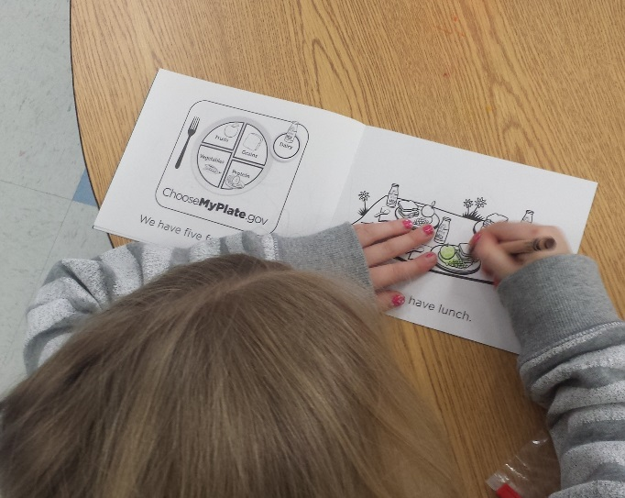
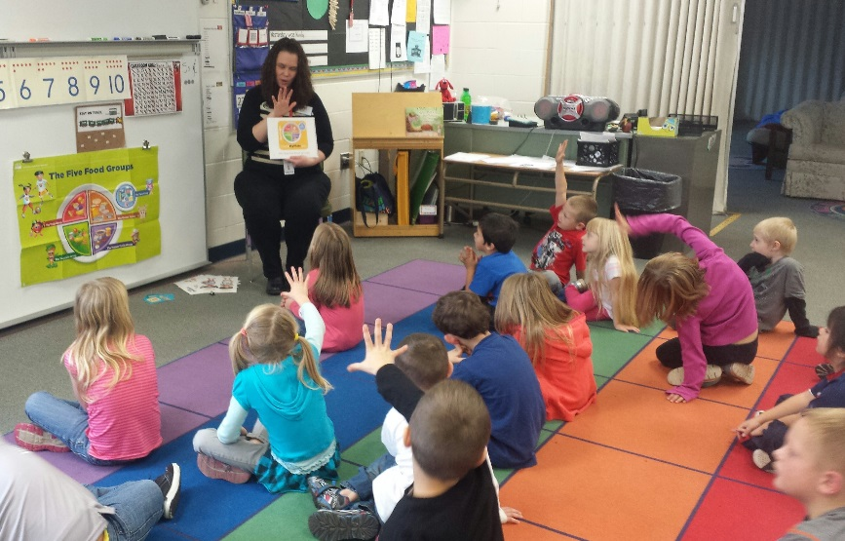

Pictures from Kindergarten Lesson at Lincoln Elementary

Educational Programming in Jackson County Community:

- Jackson County WIC: Healthy Food For Your Dollar: 7 adults
- Jackson County Food Pantry: Taylor, WI – Bringing New Life to Leftovers Lesson: 12 adults
- Jackson County Early Head Start Parent Education Program: Cook Together Eat Together Lesson and Liking New Foods Takes Time (Picky Eater Strategies): 4 adults

April had a total of 18 Nutrition Education events in Jackson County
with a total of 231 educational contacts from 11/2/15 – 11/30/15.

